**Database Project Report: Pharmacy Management System**

**1. Introduction**

In this project, we have developed a **Pharmacy Management System** database using **MySQL**. The system is designed to help manage the sales process, medicine inventory, customers, users, and manufacturers efficiently. This solution aims to improve organization, reduce errors, and enable smooth sales tracking and reporting in a pharmacy environment.

**2. Project Objectives**

* Store and manage all pharmacy-related data (medicines, users, customers, invoices, etc.).
* Ensure normalization and elimination of redundancy.
* Enable easy access to useful reports such as total sales, medicine inventory, and top-selling products.
* Use SQL queries to extract meaningful insights from the database.

**3. Entity Relationship Diagram (ERD)**

The database was designed based on an ERD that includes the following entities and relationships:

* **User**: Represents system users like admins or employees.
* **Customer**: End customers who purchase medicines.
* **Manufacturer**: Companies supplying the medicines.
* **Medicine**: Items being sold.
* **Medicine_Type**: Categories like Antibiotic, Painkiller, etc.
* **Role**: Defines whether a user is Admin or regular User.
* **Sales_Invoice**: Tracks individual purchase invoices.
* **Invoice_Details**: Tracks medicines within each invoice (Many-to-Many relation).

⚙️ **Note**: All foreign keys and relations were implemented as per the ERD for data integrity.

ERD WERE attached in the file of total broject

Database Schema

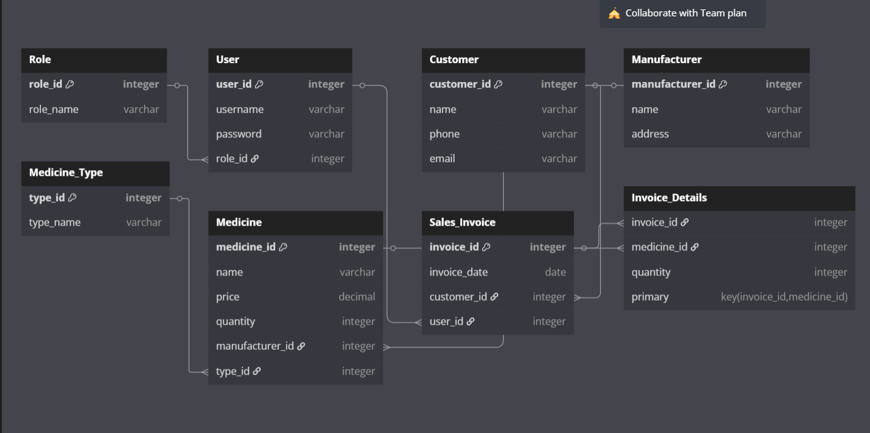

Database Schema and SQL Code

Step 1: Create Database

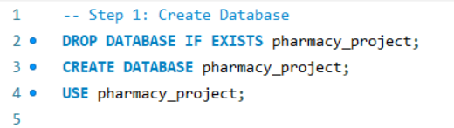

Step 2: Create Normalized Tables

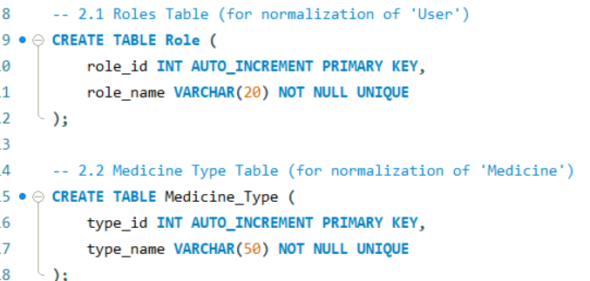

Step 3: Main Tables

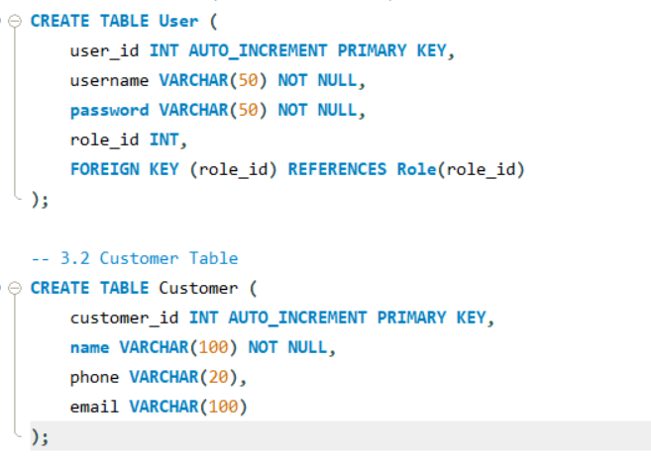

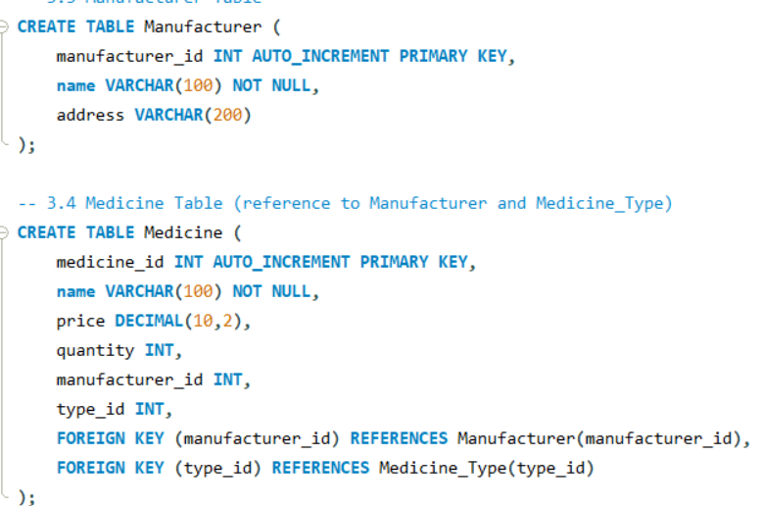

#### 

#### **Step 4: Data Insertion (Sample Records)**

Includes data for roles, medicine types, users, customers, manufacturers, medicines, invoices, and invoice details.

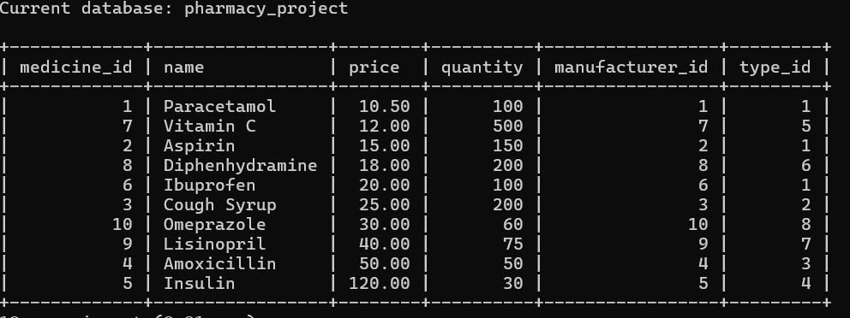

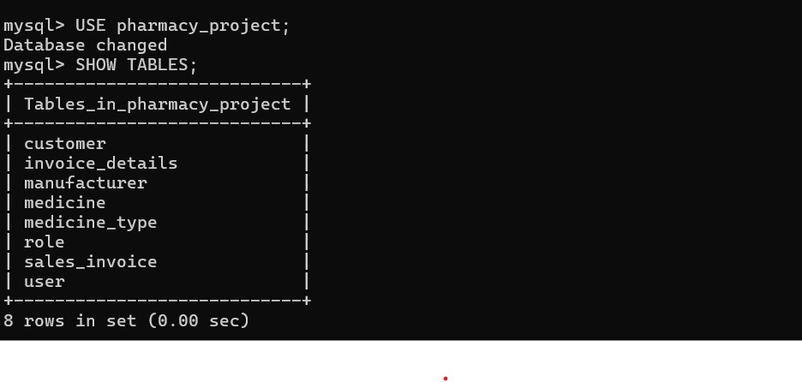

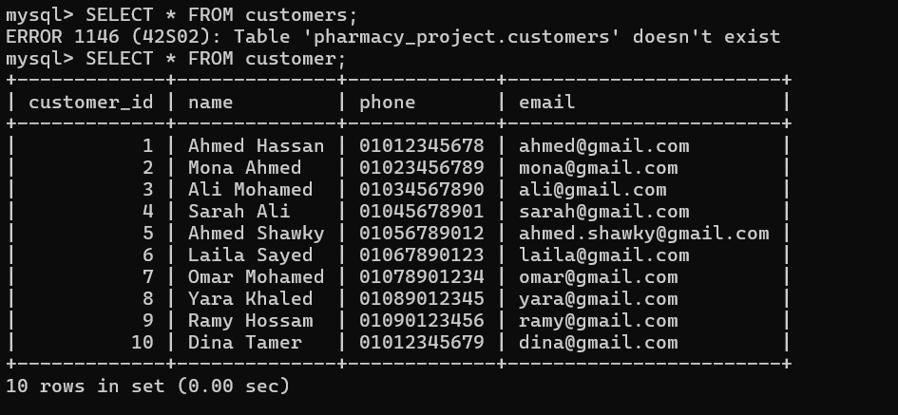

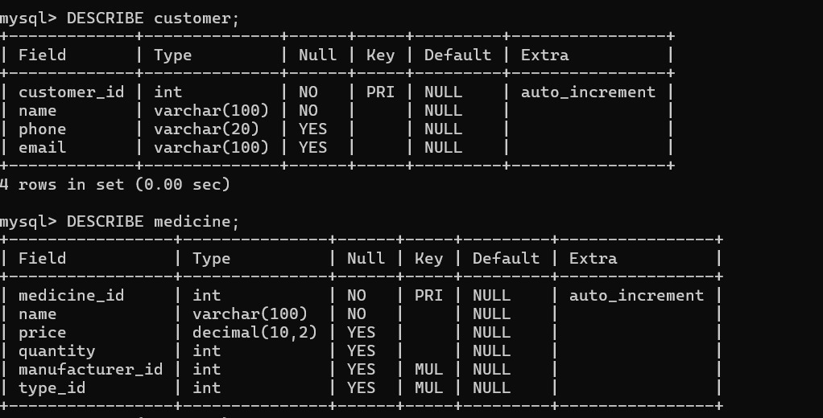

Average price of medicines

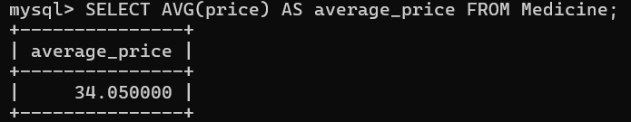

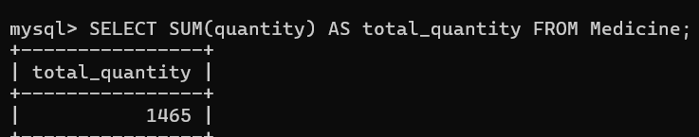

### ****Conclusion****

This project demonstrates the power of relational database design and its ability to efficiently manage and retrieve structured information in a real-world scenario like pharmacy management. The use of normalization, foreign key constraints, and SQL queries ensures a reliable and scalable database solution.

**Future Enhancements**

* Adding a **login system with encryption**.
* Introducing **triggers** to manage stock automatically after sales.
* Creating **stored procedures** for common operations.
* Building a **frontend interface** to interact with the database.